Table of Contents

**Commonly Used Constants** 4

**Unit Conversion** 5

Units 5

Conversion Ratio 5

Converting Units 5

**Free Body Diagrams** 6

**Vectors** 6

Definition 6

Components of a Vector in 2D 6

Magnitude of a Vector in 2D 7

Components of a Vector in 3D 7

Magnitude of a Vector in 3D 7

Addition and Subtraction 8

Dot Product (Scalar Product) 8

Cross Product (Vector Product) 9

Triple Scalar Product 9

Triple Vector Product 10

**Matrices** 10

Definition 10

Addition and Subtraction 10

Scalar Multiples 11

Multiplying Matrices 11

Identity Matrices 11

Transpose 12

Trace 12

Determinants 12

Inverse of a Matrix 13

Tensor Product 13

Eigenvectors and Eigenvalues 14

**Logarithmic Functions** 14

Definition 14

Laws of Logarithms 14

The Natural Exponential Function 14

The Natural Logarithm 15

**Differentiation** 15

Definition 15

Quick Reference Differentiation Rules 16

Partial Derivatives 16

**Integration** 17

Definition 17

Fundamental Theorem of Calculus 17

Substitution Rule 17

Integration by Parts 18

Cartesian Coordinates 18

Cylindrical Coordinates 18

Spherical Coordinates 18

**Significant Figures** 19

Definition 19

How to Determine the Number of Significant Figures 19

Rules of Using Significant Figures 19

**Complex Numbers** 20

Definition 20

Complex Conjugate 20

Euler's formula 21

Operations on Complex Numbers 21

Physics Applications 22

**Probability and Statistics** 22

The Bayesian View 22

General Rules 22

Joint Probabilities 23

Expectation Value 23

Variance 23

Continuous variables 24

**Series** 24

Definition 24

Geometric series 24

Taylor and Maclaurin Series 25

# **Commonly Used Constants**

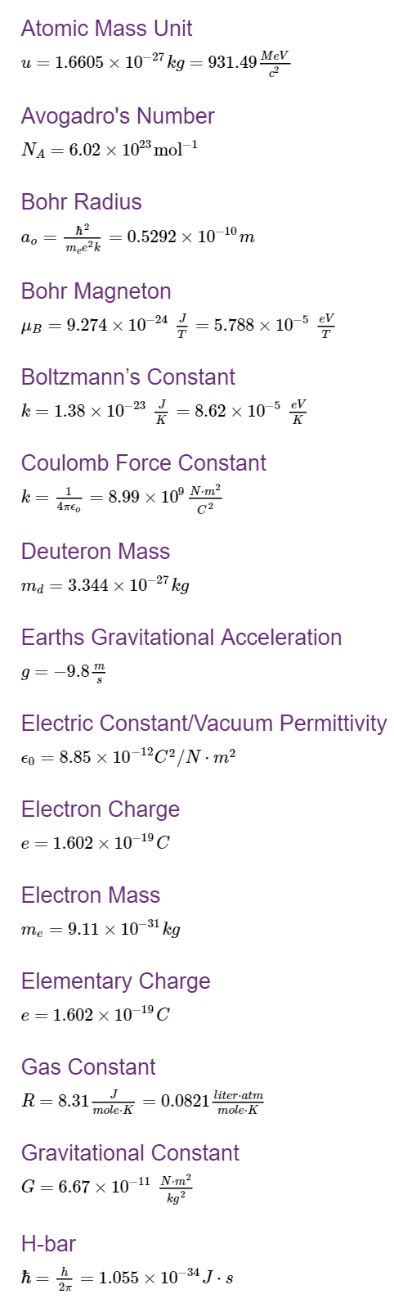

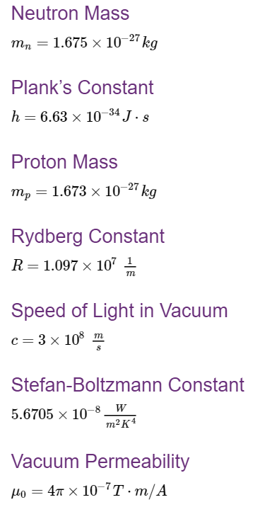

# **Unit Conversion**

## Units

Mechanics is the branch of physics in which units are derived. A given quantity can be represented in different units to depict the same amount. This is especially useful when working on a physics problem that involves multiple units.

For example:

* The distance around a running track is equal to 400 meters, 0.4 kilometers, or 0.25 miles.
* An elephant may weigh 7000 kilograms or 15 400 pounds.
  + If it takes students 10 minutes to walk to school, it also takes them 600 seconds, 0.167 hours or 0.0069 days.

## Conversion Ratio

Conversion ratios are fractions used to relate the magnitude of two units. A certain amount of one unit is in the numerator, and the equivalent amount of the other unit is in the denominator. For example:

(1 min / 60 s) = (60 s / 1 min) = 1

The numerator and denominator of the conversion ratio can be multiplied by any number without changing the ratio. For example, if 1 minute is multiplied by 10, it is equal to 10 minutes divided by 600 seconds. Therefore, to convert between two units it is often useful to use ratio rules.

**Note:** A conversion ratio can only be used to convert between the same type of unit; for example: a time unit to another time unit, not a time unit to a distance unit.

## Converting Units

Converting between units can be done with a conversion ratio. To convert between units, you must multiply your quantity by the conversion ratio in a such a way that the original unit cancels out.

In this example, we are converting 1 min to hours:

$$1 min*\frac{1 Hour }{60 min}=\frac{1}{60}hours=0.0167 hours$$

If a quantity has multiple units, a conversion ratio can convert one or more of them.

In this example, we are converting 32.7 kilogram•meters/second to kilogram•meters/minute.

$$32.7\frac{kg.m}{sec} *\frac{60sec}{1min}=1962 kg.m/min$$

# **Free Body Diagrams**

**Free body diagrams** are used to summarize all forces acting on an object.

* **Object:** drawn as rectangle or square in center of diagram
* **Forces:** Arrows stretch outwards from the object (can be push or pull)
* **Magnitude:** Represented by length of arrows
* **Direction:** Represented by direction of arrows

F1

OBJECT

F2

In this diagram, F1 and F2 are being applied in the same direction,  
but F1 has half the magnitude of F2

The net force on the particle can be found quickly by vector addition.

# **Vectors**

## Definition

**Vectors**: Have both a magnitude and direction (example: velocity of 15 m/s east)

* Vectors are typically written in boldface**a**, or a letter with an arrow above it a⃗.
* Vectors can be represented by an arrow (**magnitude** = length of arrow, **direction** = direction of arrow)

**Scalars**: Have magnitude only (example: speed of 15 m/s)

**Other common examples of vectors**:

* Force, momentum, acceleration, angular momentum, magnetic fields and electric fields

## Components of a Vector in 2D

Any vector can be written as a sum of a set of orthogonal vectors. This allows us to define the components of the vector.

**2D Form of a vector**a⃗ =(x,y)

y

a⃗

x

The components x and y of the vector can be expressed using the magnitude and angle, θ as:

x=|a⃗ |cos(θ)

y=|a⃗ |sin(θ)

The components can be arranged in a column to represent the vector***.***a⃗ =[x y]

## Magnitude of a Vector in 2D

**Magnitude of a⃗** (diagram above) is denoted with absolute bars **|a⃗ |** and is found using Pythagorean theorem, sqrt(x2 + y2)

Let e⃗x  be a vector of magnitude 1 pointing along the x axis, and e⃗ y be a vector of magnitude 1 pointing along the y axis. Then the vector a⃗ can be written as:

a⃗ =xe⃗x+ye⃗y

## Components of a Vector in 3D

**3D Form for the vector**b⃗ =(x,y,z)**:**

z

b

x

y

**The components x, y and z of the vector can be expressed using the magnitude, and angles, α, β, and γ as:**

x=|b⃗ |cosα

y=|b⃗ |cosβ

z=|b⃗ |cosγ

The components can also be arranged in column form to represent the vector***.***b⃗ = [x y z]

## Magnitude of a Vector in 3D

**Magnitude of b⃗** (diagram above) is denoted with absolute bars  **|b⃗ |**and is found using Pythagorean theorem twice, once for each of the two triangles.

Let e⃗ x be a vector of magnitude 1 pointing along the x axis, e⃗ y be a vector of magnitude 1 pointing along the y axis, and e⃗ z be a vector of magnitude 1 pointing along the z axis. Then the vector b⃗ can be written as:

b⃗ =xe⃗ x + ye⃗ y + ze⃗

## 

## Addition and Subtraction

Two or more vectors can be added. The sum of vectors (or resultant vectors) can be found geometrically. This is found by arranging vectors head to tail, and connecting the tail of the first vector to the head of the last vector.

a

c

b

c⃗ =a⃗ + b⃗

The sum of vectors may also be found by adding the components of the vectors.

Let a⃗ =x1e⃗ x+y1e⃗ y+z1e⃗ z and b⃗ =x2e⃗ x+y2e⃗ y+z2e⃗ z

Therefore: c⃗ =(x1+x2)e⃗ x + (y1+y2)e⃗ y + (z1+z2)e⃗ z

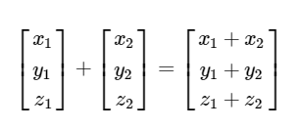The sum of vectors may also be found by vector column addition.

Subtracting vectors is similar to adding vectors. A vector that is equal in magnitude to b⃗ , but opposite in direction is written as −b⃗ .

The difference between two vectors can be found using:

c⃗ =a⃗ +(−b⃗ )

## 

## Dot Product (Scalar Product)

The dot product of vectors is often considered as the multiplication of two vectors.  
It is defined to be:

and can also be found using components:

If **a⃗ ⋅b⃗ =0**, and we know that a⃗ ≠0 and b⃗ ≠0 it then tells us that cosθ=0:

* Therefore, θ=90∘, 270∘ and a⃗ and b⃗ are both **orthogonal** vectors.

An example of when the dot product is used in physics is for calculating work:



## Cross Product (Vector Product)

The cross product of vectors is defined to be:



It may also be calculated using:

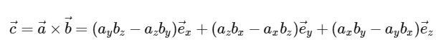

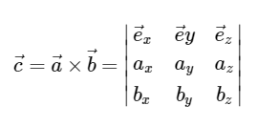The cross product can also be calculated using a matrix method to calculate the determinant:

An example of when the cross product is used in physics is when calculating the magnetic induction. The equation for this is:



## Triple Scalar Product

The triple scalar product of three vectors is defined by:

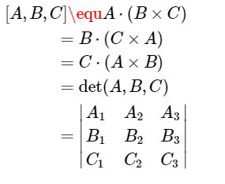

The triple scalar product is used to calculate the volume of a parallelepiped with the side lengths of A,B,C:

### 

## Triple Vector Product

The triple vector product is defined as the cross product of one vector with the cross product of the other two.

The two important properties of vector products are as follows:



These properties come up very often in vector calculus, especially when using gradients.

# **Matrices**

## Definition

A **matrix** is an array of numbers arranged in rectangular form that can be treated as a single object. The numbers in the array are called the entriesin a matrix.

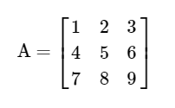

A matrix with the same number of rows and columns is called a **square matrix**.

Matrices are commonly used in physics. Examples include representations of operators in quantum mechanics, Jones matrices in optics and rotation matrices in classical mechanics.

## Addition and Subtraction

To add and subtract matrices, they must be the same size. (Ex. 2 x 2 matrix can only be added to a 2 x 2 matrix.)

The sum of two matrices of the same size is found by adding together entries that are corresponding, or in the same spot in the matrix.

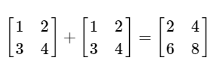

The difference between two matrices of the same size is found by subtracting an entry from the corresponding entry in the other matrix.

## 

## Scalar Multiples

By multiplying each entry in a matrix by a scalar, you obtain the scalar multiple matrix.

Scalar multiples are using in Jones matrices, when manipulations are needed to simplify a Jones matrix in order to identify the optical elements involved.

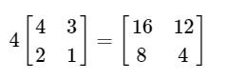

## Multiplying Matrices

The definition of matrix multiplication requires that the number of columns in the first matrix are the same as the number of rows of the second matrix.

To multiply matrices, take the entries of a single row in the first matrix, and a single column in the second matrix. Multiply corresponding entries together and then add up all of the resulting products. Continue this process to find each entry in the product matrix.

**Note:** It is important to remember when multiplying matrices that AB≠BA

## Identity Matrices

Identity matrices are denoted by I and are square matrices with 1's on the main diagonal, and 0's off the main diagonal. The following are identity matrices:

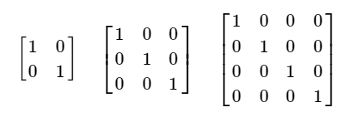

An identity matrix has similar attributes as the number 1, but is useful when doing matrix arithmetic. That is:

### 

## Transpose

The transpose of a matrix is found by interchanging the rows and columns of that matrix.

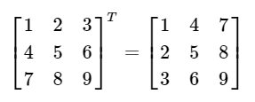

### 

## Trace

The trace of a matrix is found by adding up all entries on the main diagonal of that matrix. The main diagonal of a matrix runs from the top left entry diagonally down to the bottom right entry. This means that the trace is only defined for square matrices.

## 

## Determinants

The determinant of a matrix, often notated as det(A), is found easily using cofactor expansion.

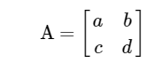

In a 2 x 2 matrix, the determinant is found by:



When a matrix is larger than a 2x2 matrix, one method used is called cofactor expansion.

The minor of an entry is found by taking the determinant of a 2 x 2 matrix that appears when you “block out” the row and column that cross at that entry.

The cofactor is then found by multiplying the minor by (−1)i+j, where i is the row number, and j is the column number .This method is used to find the appropriate sign for the cofactor. The cofactor is then multiplied by the original entry.

This is done for all entries in a row or column of the original matrix, and these products are summed to find the determinant of the original matrix.

The determinant helps us decide whether a matrix is invertible or not, because if the matrix is invertible, the determinant must be non-zero. Determinants are also very important for systems of linear equations.

## Inverse of a Matrix

If A is a square matrix, and if B is found to be a matrix of the same size such that AB=BA=I, then A is said to be invertible, and B is called the inverse of A.

Note that if |A|=0 then there is no inverse.

## Tensor Product

Finding the tensor product is another way to multiply matrices. In quantum mechanics, coupled systems are described by tensor products.

For the two matrices:

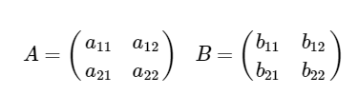

The tensor product is found:

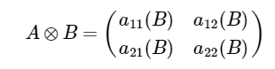

## 

## Eigenvectors and Eigenvalues

In the equation:



λ is a scalar known as the eigenvalue, and r⃗ is known as the corresponding eigenvector. If A is a Hermitian matrix, the corresponding eigenvalues are real and its eigenvectors are orthogonal.

To determine the solutions for the eigenvalues, the following equation is used:



where I is the identity matrix. After solving for the eigenvalues, the corresponding eigenvectors can be found by solving the above eigenvalue equation.

# **Logarithmic Functions**

## Definition

y=ax is an exponential function, for example y=102y=102. A logarithmic function may be used to significantly simplify complicated calculations. Putting functions in terms of logarithms is simply reworking the function to be written in different way.

The logarithm of the number y to a given base of a, may be written as the exponent to which the base aa must be raised to produce the number y.  Therefore: if y=ax, then logay=x.

Using the previous example of y=102, we can do the following manipulations:



## Laws of Logarithms

If x and y are positive numbers, then:

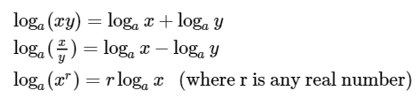

## The Natural Exponential Function

It was discovered that many calculus formulae could be greatly simplified with a specific number. This number must represent the base a, so that the slope of the tangent line to y=ax at (0,1), is exactly 1. This number, e, is sometimes called Euler’s number. The function y=ex is often referred to as the natural exponential function.

An example of the natural exponential function is seen in radioactive decay.

## The Natural Logarithm

Natural logarithms are helpful because they use the most convenient base number, e. The special notation for a natural logarithm is:



The number e is useful in many physics equations because it can be used to rewrite trigonometric functions.

# **Differentiation**

## Definition

The derivative is geometrically represented as the slope of the tangent at point (a,f(a))(a,f(a)). Generally speaking, a derivative can be thought of as how much a quantity is changing at a given point.

A simple example of this arises in mechanics:

The equation for velocity is:

v⃗ =ΔsΔtv→=ΔsΔt

This equation can be represented in graph form, where the slope of the graph is equal to the average velocity. When picturing an instantaneous velocity, the change in position and time can be thought of as infinitesimally small, and are therefore ds and dt, respectively. This being said, it shows that the instantaneous velocity is:

v⃗ =dsdtv→=dsdt

This can be graphically represented by the slope of the tangent line at a point.

## Quick Reference Differentiation Rules

## Partial Derivatives

Partial derivatives are used when a function has two variables, but only one is allowed to vary, while the other variable is kept constant. The notation for a partial derivative of f(x,y) with respect to x is shown as:



The following is an example of a partial derivative:

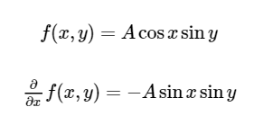

# **Integration**

## Definition

Integration is defined two ways: as the inverse to differentiation, and as the area under a curve.

A simple example of this is seen in mechanics:

The derivative of position with respect to time is velocity. Integration is defined as the inverse to differentiation, and therefore when the velocity is integrated, it gives position. Integration is also defined as the area under a curve, which is shown in a graph of acceleration.

## Fundamental Theorem of Calculus

**Part I:**

If is continuous on [a,b], then the function gg defined by:

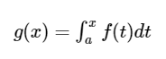

is continuous on [a,b] and differentiable on (a,b), and g′(x)=f(x)

**Part II:**

If ff is continuous on [a,b], then:

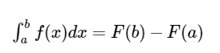

where F is any antiderivative of f, that is, a function such that F′=f.

## Substitution Rule

If u=g(x) is differentiable function whose range is an interval I and f is continuous on I, then:

Note that if u=g(x), then du=g′(x)dx.



The substitution rule also says that it is permissible to operate with dx and du after integral signs as if they were differentials.

An example is to calculate ∫e3xdx.

If we let u=3x, then du=3dx, so dx=13du. Therefore



## 

## Integration by Parts



Let u=f(x) and v=g(x)v=g(x), then du=f′(x)dx and dv=g′(x)dx.   
Therefore:



An example is to calculate ∫x cosx dx.

Let u=x and dv=cosxdx, then du=1dx and v=sinx. Therefore:



## Cartesian Coordinates

The world is 3-dimensional. The cartesian coordinate system has 3 axes; x, y, and z with a common origin.

## Cylindrical Coordinates

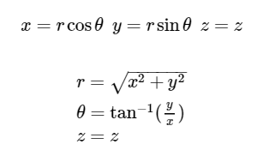

### 

## Spherical Coordinates

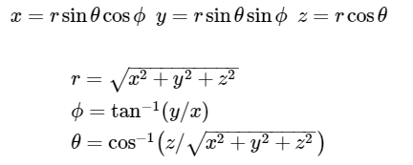

# **Significant Figures**

## Definition

Significant figures (or digits) tell us how precisely a quantity is known.

For example, in the 2004 Olympics 100m finals, the gold medal time was **9.85s**, and the silver medal time was **9.86s**.

The number of significant digits in these times is 3.

With 3 significant figures we can pick the winner, but with 2, we cannot.

## How to Determine the Number of Significant Figures

There are several steps to determining the number of significant figures of a value:

1. Neglect all leading zeros. Example 00035281
2. Rewrite using scientific notation: N=±a×10bN=±a×10b  
   where a is a number between 1 and 10 and b is a positive or negative integer. Example 35281=3.5281×10435281=3.5281×104
3. Count the number of digits excluding the powers of 10.

Example: 3.5281×1043.5281×104: 5 significant figures

## Rules of Using Significant Figures

When multiplying and dividing measured quantities, there should be as many significant figures in the answer as there are in the measurement with the least number of significant figures.

Example: 15.3422.5=6.136815.3422.5=6.1368

which becomes 6.1 (two significant figures)

When adding or subtracting measured quantities, there should be the same number of decimal places in the answer as there are in the measurement with the least number of decimal places. For addition and subtraction, the number of significant figures is NOT important.

Example:10.72+5.0+7.216=22.93610.72+5.0+7.216=22.936 with the correct significant figures 22.9

Note that it is important to keep more significant figures in intermediate steps to avoid error.

# **Complex Numbers**

## Definition

A complex number z has the form z=x+iy, where x and y are real numbers, and i=sqrt−1. The number ii is referred to as the imaginary unit, and allows us to take the square root of negative numbers. There is an important pattern with imaginary numbers.

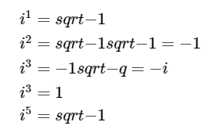

This pattern will repeat, and the power of ii can be simplified by dividing the exponent by 4, and using the value found by the remainder as the exponent for ii.

For example, i25=i, because 25/4=6 remainder 1 and i1=i.

 Any complex number z can be expressed in terms of Cartesian components, x=Re z, and y=Im z. The number xx is called the real part of z and the number y is the imaginary part of z.

The ordered pair z=(x,y) can be plotted on a plane called the Argand plane, where x is the real axis and y is the imaginary axis.

From this graph we can see that:

x=rcosθ

y=rsinθ

and

z=r(cosθ+isinθ)

## 

## Complex Conjugate

The complex conjugate of z, where z=x+iy can be denoted as z¯ or z∗, and is defined as:

### 

## Euler's formula

Euler's formula is important in relating complex exponential functions to trigonometric functions.

Using the Taylor series as our guide, we define

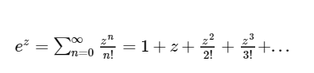

If we set z=iyz=iy it is easy to see that:

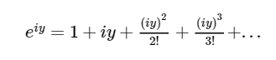

Which can be broken up into real and complex parts:

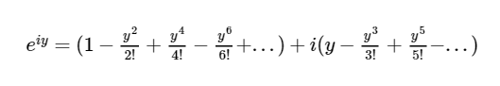

Therefore for any real number y,



Recall from the above diagram that



and when used with Euler's formula, we find the very useful polar form representation, z=reiθ. In the polar form, r is called the modulus or magnitude of z, and is its distance from the origin. The angle θ is the argument or phase of z.

The complex conjugate can be written in polar form as:



## Operations on Complex Numbers

**Addition and Subtraction:**

Similar to adding components of vectors, to add or subtract complex numbers group the real and complex parts separately:



**Multiplication:**

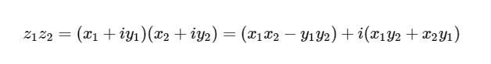

**Division:**

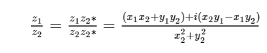

**De Moivre`s Theorem:**

If z=r(cosθ+isinθ) and n is a positive integer, then



This says that in order to take the nth power of a complex number, we take the nth power of the modulus, and multiply the argument by n.

## Physics Applications

Complex numbers help form the mathematical backbone to many important areas in physics.

For example, complex numbers show up in the Schrödinger equation, description of electromagnetic waves and fluid dynamics.

# **Probability and Statistics**

## The Bayesian View

Probabilities are assigned based on your prior knowledge and your assumptions. A probability is thus a measure of your state of knowledge. It is a measure of how likely it is for an event to happen. Probabilities are updated as we gain new information.

Example: Based on latest satellite images, the probability of rain tomorrow is 80%.

## General Rules

Consider a set S whose elements represent outcomes of events.  
Example: S=the set of outcomes 1,2,3,4,5,6 for a roll of a die. If each outcome is equally likely then the probability of outcome j is:

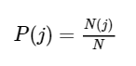

N(j) represents the number of elements corresponding to outcome jj.  
N represents the total number of elements.

What is the probability of obtaining a 6 on a standard, 6-sided die?



Note that the total number of elements is the sum of the elements corresponding to each outcome:

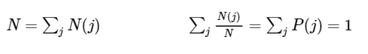

## Joint Probabilities

For mutually exclusive events (events that are independent of each other):



Therefore, in our dice example the probability of rolling two consecutive sixes is:

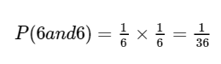

## Expectation Value

The expectation value is the ensemble average, or mean.

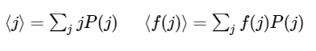

For our dice example:

## 

## Variance

Variance is defined as the spread around the average



For our dice example:

Using,



we can calculate the variance:

## 

## Continuous variables

The probability that an outcome lies in a certain interval P(x)dx is defined by the probability that an outcome lies in an infinitesimal interval dx around x. Thus the probability of an outcome in the interval between values a and b is:



All we are doing is adding up the probabilities of the outcomes corresponding to the subset a<x<b.

Thus the probability of an outcome lying somewhere in the entire interval is 1. This is called **normalization**.

## 

# **Series**

## Definition

A sequence is a list of numbers written in a definite order.



The notation for a term in that sequence is an and is generally referred to as the nthterm. In an infinite sequence, each term an is followed by the term an+1an+1.  The above sequence can also be denoted as:



A series is the sum of the terms in an infinite sequence.

## Geometric series

An example of an infinite series is the geometric series:

## 

## Taylor and Maclaurin Series

The Taylor series is defined as:

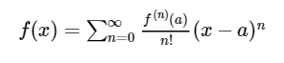

The special case of the Taylor series for when a=0 is called the Maclaurin series and is defined as:

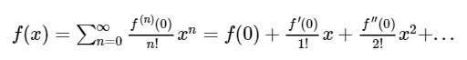

Here are some other important Maclaurin series:

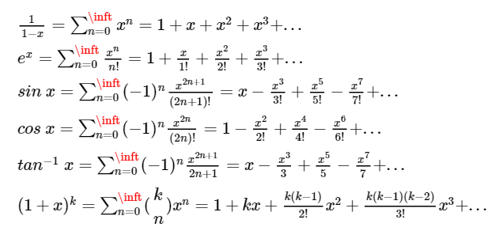

In physics, Einstein's theory of special relativity Maclaurin series.